BT 5240 Computational Systems Biology
Assignment 3
- Krushanu Patki
BE23B007

- Question 1 - FBA Fundamentals

- The values of the biomass flux obtained by performing FBA and pFBA, under both aerobic and anaerobic conditions, in minimal media are given as follows:

 | In units ($\frac{mmol}{gDW -hr})$
FBA solution under aerobic conditions | 0.10000000000000105
pFBA solution under aerobic conditions | 0.09999999999999824
FBA solution under anaerobic conditions | 0.09999999999999988
pFBA solution under anaerobic conditions | 0.09999999999999988

Table 1: FBA and pFBA solutions under different conditions

- While FBA and pFBA produce different solutions for the biomass flux in the case of aerobic medium, they produce identical solutions for the same in the case of anaerobic medium.
- In general, FBA and pFBA produce different flux distributions in both the aerobic and the anaerobic cases. To demonstrate this, we identify the reactions where the difference between the fluxes calculated in FBA and pFBA is greater than 0.01 $(\frac{mmol}{gDW -hr})$ (an arbitrarily large number in this context).

- In the case of the aerobic medium, 19 such reactions were obtained:

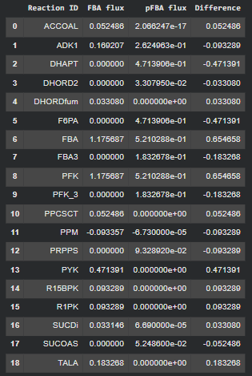
Figure 1: Reactions with substantially different fluxes after performing FBA and pFBA, in the aerobic case

- In case of the anaerobic medium, 16 such reactions were obtained:
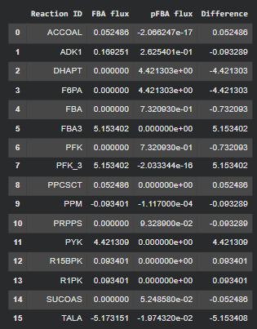
Figure 2: Reactions with substantially different fluxes after performing FBA and pFBA, in the anaerobic case

- FVA was performed by constraining the biomass flux to be equal to the maximum biomass flux possible (fraction_of_optimum = 1, for a given model and medium).
- The reactions where the absolute difference between their upper bounds and lower bounds was observed to be greater than or equal to 900 ($\frac{mmol}{gDW -hr})$ (an arbitrarily large number, here), were identified as the ones with ‘wide allowable flux ranges’.
- In the aerobic case, 76 such reactions were obtained, some of which are given as follows:
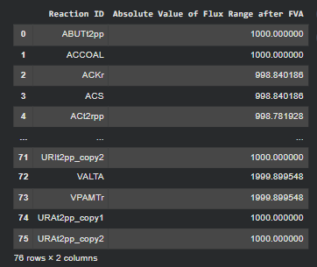

Figure 3: Reactions with ‘wide allowable flux ranges’ in the aerobic case
- In the aerobic case, 76 such reactions were obtained, some of which are given as follows:
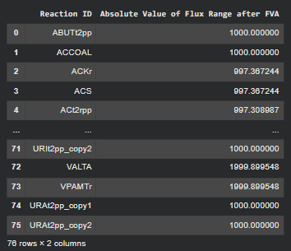

Figure 4: Reactions with ‘wide allowable flux ranges’ in the anaerobic case

- Flux Balance Analysis (FBA) provides the optimum (maximum) value of a pre-defined objective function (here, the biomass objective function) subject to a Linear Programming Problem (LPP) that includes constraints placed on the upper and lower bounds of the fluxes carried by all the reactions in a genome-scale metabolic model (GEM).
- Thus, FBA predicts the cellular phenotype for a particular objective; for instance, the objective could be defined in terms of ATP maintenance reaction in environmental conditions where the cell may prefer survival and energy storage over rapid cell division and proliferation.
- In this case, FBA has been used to predict the biomass flux for the given E. coli GEM under aerobic and anaerobic conditions in minimal media. It must be noted that while the value of the objective function (here, the biomass flux) is unique for the given LPP, the values of the fluxes through other reactions are not. Thus, multiple flux distributions in the solution space result in the same maximum value for the biomass flux, which is the objective function here.
- Parsimonious FBA (pFBA) provides a solution for the flux distribution that minimises the number of non-zero fluxes. Thus, analysing the flux distribution thereby generated allows the identification of reactions that are essential for cellular growth in a given environment (e.g., constraints imposed by the medium), and others that represent alternative pathways, which may require more flux to achieve the same growth rate. pFBA can also be used to identify blocked reactions.
- Here, reactions whose fluxes substantially differed between the flux distributions provided by FBA and pFBA (in either the aerobic or the anaerobic case), represent either one of the two kinds of reactions:
- Reactions whose fluxes were reported to be non-zero in the flux distribution obtained after performing FBA, but were set to zero after performing pFBA, represent reactions that may either be unable to carry a flux in the given minimal medium, or others that are components of alternative pathways (as described above), or may be responsible for reducing the biomass flux if they carry a non-zero flux.
- Reactions whose fluxes were reported to be zero in the flux distribution obtained after performing FBA, but became non-zero after performing pFBA, represent reactions that are necessary, at least in the given medium, to achieve the optimum growth rate under the conditions imposed by pFBA. These could also be reactions that are not essential for cellular survival but are responsible for achieving the optimal biomass flux.
- Whether all the reactions that show a substantial change in their flux from the FBA-derived flux distribution to the pFBA-derived one are essential can be determined by performing suitable deletion analyses.
- Flux Variability Analysis (FVA) provides the maximum and minimum values of each of the reaction fluxes subject to constraints of the biomass objective function (here, fraction_of_optimum was set to 1). Thus, the results of FVA can be used to describe the theoretical metabolic capabilities of the cell in the given media, subject to maximisation of the biomass objective function, in the given environment in which the cells are cultivated(such as the media).
- Here, FVA was utilised to determine the reactions with an arbitrarily wide range of fluxes in different media (aerobic and anaerobic minimal media). These reactions can carry fluxes over a relatively wide range of values and still contribute to a relatively high biomass flux; thus, a relatively small change in the flux carried by these reactions may not substantially reduce the biomass flux from its optimal value, as calculated by FBA.
- For instance, since none of these are exchange reactions, one may conclude that only certain media formulations that allow fluxes through exchange reactions only within a relatively small range of values are necessary to obtain a relatively high biomass flux. This may be important for certain media components that are expensive to obtain, difficult to store, etc.
- If a relatively large number of reactions from a certain pathway are represented here, one may conclude that altering the flux through such a pathway may not substantially change the biomass flux from its optimal value. This may be important for metabolic engineering applications, where attempts could be made to reduce the flux carried by a certain biosynthetic pathway and diverted to another one that produces a product of interest.

- Parts (a) and (b)
The modified objective function in each case (aerobic and anaerobic) was cast as a weighted sum of the ethanol exchange reaction and the biomass reaction such that the weights added up to 1: $model.objective= wt*reaction_etoh.flux_expression+(1 - wt)* reaction_biomass_flux_expression; 0 ≤ wt ≤ 1$
- We iterated through different weights for the ethanol exchange reaction in the range [0, 1] with a step size of 0.01, and reported only those for which a non-zero biomass flux was obtained.
- For the aerobic case, the following results were obtained:
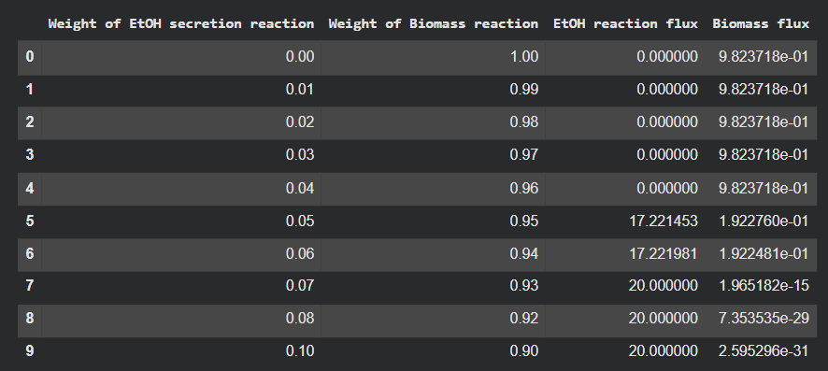
Figure 5: Modified objective functions with different weights for the ethanol exchange reaction that reported a non-zero biomass flux in the aerobic case
- The variation of the biomass flux with the weight of the ethanol exchange reaction was visualised as follows:
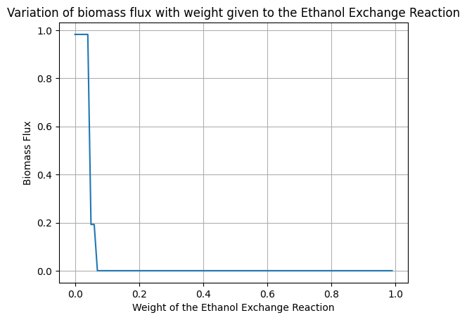
Figure 6: Variation of the biomass flux with weights of the ethanol exchange reaction, in the aerobic case
- When wt = 0, the biomass flux corresponding to FBA without the introduction of the ethanol exchange reaction in the objective function is obtained. For successive values in the range (0, 0.1), the value of the biomass flux reduces sharply. For wt ˃ 0.1, the biomass flux remains zero, as shown in the plot and the table above.

- For wt = 0.05, we observe the first sharp decrease in the biomass flux. Therefore, we scrutinise the flux distribution in this case, and report the following 22 reactions where the absolute difference between their values obtained after performing FBA and by incorporating the ethanol exchange reaction in the objective function was greater than or equal to 5 ($\frac{mmol}{gDW -hr})$:

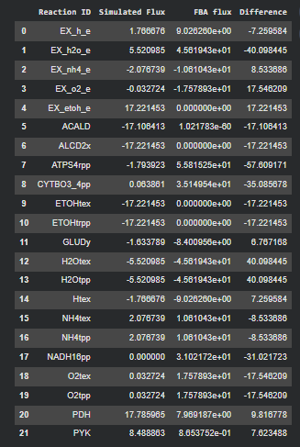

Figure 7: Reactions with substantial change in their fluxes after the incorporation of the ethanol exchange reaction in the objective function; here, wt = 0.05, aerobic case

- For the anaerobic case, the following results were obtained:
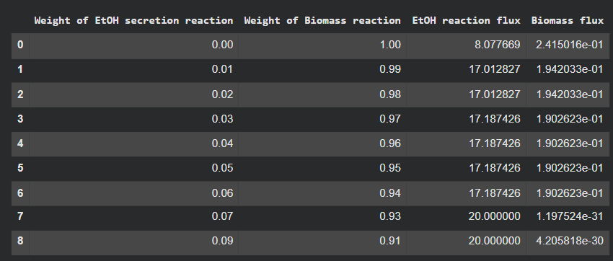
Figure 8: Modified objective functions with different weights for the ethanol exchange reaction that reported a non-zero biomass flux in the aerobic case
- The variation of the biomass flux with the weight of the ethanol exchange reaction was visualised as follows:

Figure 9: Variation of the biomass flux with weights of the ethanol exchange reaction,
in the anaerobic case
- When wt = 0, a non-zero ethanol flux is obtained; in this case, the biomass flux is lower than that obtained by performing FBA under aerobic conditions. For successive values in the range (0, 0.09), the value of the biomass flux reduces sharply. For wt ˃ 0.09, the biomass flux remains zero, as shown in the plot and the table above.

- For the sake of consistency, we scrutinise the flux distribution for wt = 0.05, and report the following 22 reactions where the absolute difference between their values obtained after performing FBA and by incorporating the ethanol exchange reaction in the objective function was greater than or equal to 5 ($\frac{mmol}{gDW -hr})$:
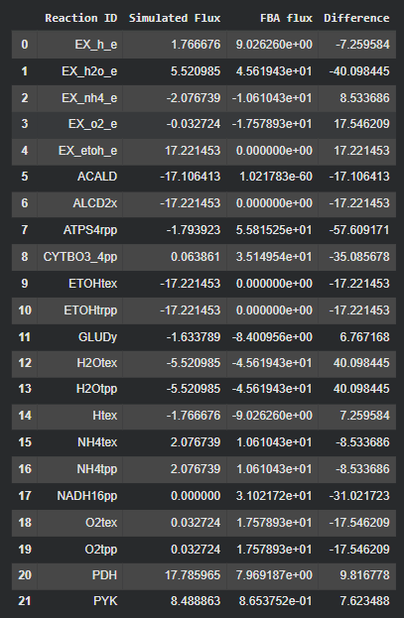
Figure 10: Reactions with substantial change in their fluxes after the incorporation of the ethanol exchange reaction in the objective function; here, wt = 0.05, anaerobic case
- We observe that the biomass flux, flux through the ethanol exchange reaction, and the fluxes through the reactions show above are close to each other when compared across the aerobic and anaerobic cases, when wt = 0.05. This need not be true in general; for instance, the values of the biomass flux and the flux through the ethanol exchange reaction vary substantially in the range [0, 0.04] of the parameter ‘wt’, across the aerobic and anaerobic cases.
- At higher values of the parameter ‘wt’, the difference between the aerobic and anaerobic flux distributions is not substantial, indicating that a switch from aerobic respiration to anaerobic respiration is presumably the primary reason for the trend observed. However, at lower values of the parameter ‘wt’, the flux distributions differ substantially across the aerobic and anaerobic cases, indicating that active aerobic respiration in the aerobic case is responsible for the trend observed. This can be verified by obtaining Figures 7 and 10 for wt = 0.04.
- Thus, we conclude that alterations made to central metabolism pathways by means of environmental changes or by altered cellular objectives lead to substantial changes in the overall flux distribution and the metabolic capabilities of the cell.

- Part (c)

- We set the value of the upper bound of the oxygen exchange reaction to different fractions of the upper bound provided in the medium in the range [0,1] with a step size of 0.01, and obtain the biomass flux and the flux through the ethanol exchange reaction for each case; moreover, wt is set to wt = 0.05 here.
- The variation of biomass flux and the flux through the ethanol exchange reaction for various values of the upper bound of the oxygen exchange reaction are given as follows:

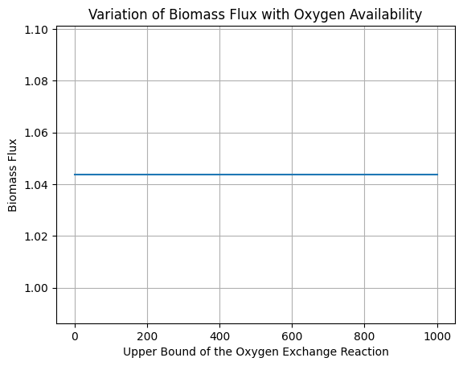
Figure 11: Variation of the Biomass Flux with Oxygen Availability

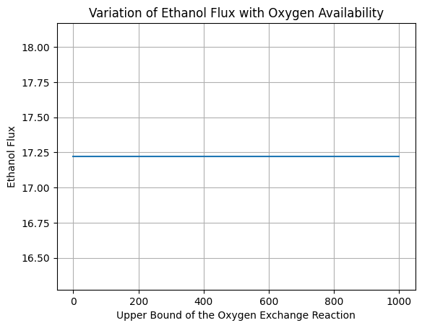
Figure 12: Variation of the Ethanol Flux with Oxygen Availability

- We observe that the biomass flux and the flux through the ethanol exchange reaction do not change with oxygen availability for wt = 0.05 for the ethanol exchange reaction in the objective function. Upon simulation, this was found to be true for wt = 0.01 as well.
- However, for a given upper bound of the oxygen exchange reaction, for different values of the parameter ‘wt’, the biomass flux and flux through the ethanol exchange reaction vary with ‘wt’, as shown above.

- Question 2 - Cross Pathogen Target Discovery:

Bacterium | Number of Genes | Number of Metabolites | Number of Reactions | Reaction-to-gene ratio
M. tuberculosis | 661 | 825 | 1025 | 1.55068
A. baumannii | 709 | 888 | 1015 | 1.43159

Table 2: Number of genes, metabolites and reactions in the two models

- A higher number of genes, in this case, corresponds to a higher number of metabolites, but does not correspond with a higher number of reactions.
- This is illustrated by the fact that while M. tuberculosis has a lower number of genes as compared to A. baumannii, it has a higher number of reactions.

- M. tuberculosis is an obligate intracellular human pathogen; thus, it may rely on host pathways for several metabolic functions, and may have lost certain genes that encode enzymes required for metabolism over time. On the other hand, while A. baumannii is an intracellular human pathogen, it is commonly found in hospital environments and has been isolated from soil samples as well; thus, it may have to encode relatively more number enzymes as compared M. tuberculosis in order to utilise different nutrients available in different environments.
- This is also reflected in the higher number of metabolites that the A. baumannii metabolic model can utilise, as compared to M. tuberculosis, which is an obligate human pathogen.
- However, there is no substantial difference in the number of reactions present in the two models, indicating that more enzymes in the M. tuberculosis model can catalyse more than reaction as compared to those in the A. baumannii model. Thus, while M. tuberculosis may have evolved to encode a smaller set of enzymes due to the environmental constraints imposed by its obligate pathogenic lifestyle, A. baumannii may have evolved to encode a larger set of enzymes that help it survive in different environments.

- Essential genes were determined using the find_essential_genes() function in the cobra.flux_analysis module.
- The M. tuberculosis model was reported to have 188 essential genes, some of which are given as follows:
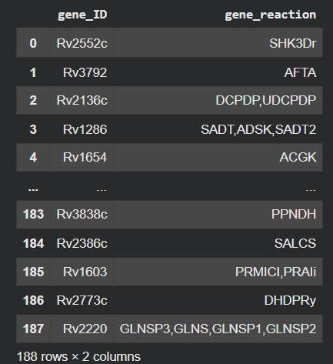
Figure 13: Some essential genes and corresponding reactions in the M. tuberculosis model
- The A. baumannii model was reported to have 74 essential genes, some of which are given as follows:

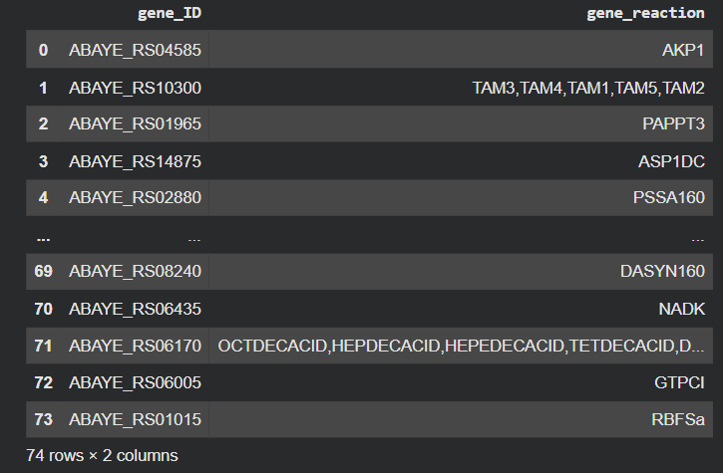
Figure 14: Some essential genes and corresponding reactions in the A. baumannii model
- The essential genes in each model have been exhaustively listed in the .py file containing the relevant code.

- The essential genes that encoded the same set of reactions in the two models were considered as ‘common essential genes’.
- For example, if gene_1 in a model encoded enzymes for reactions r_1 and r_2 and gene_2 in the other model encoded enzymes for reactions r_1 and r_2, these two genes were considered ‘common essential genes’.
- However, if gene_1 in a model encoded enzymes for reactions r_1 and r_2 and gene_2 in the other model encoded enzymes for reactions r_1 and r_3, these two genes were not considered ‘common essential genes’, given that they do not encode different proteins that have different sets of functions.
- 15 genes were identified as ‘common essential genes’ based on the above argument:
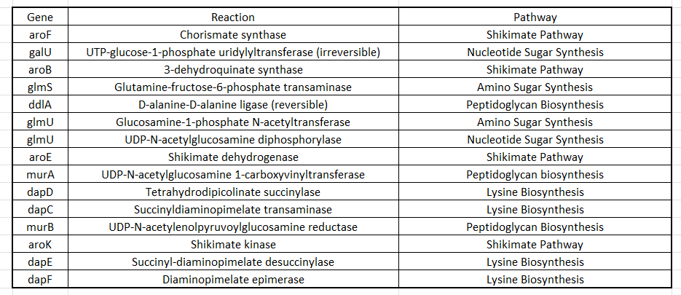
Table 3: Essential Genes common to the two models and the reactions catalysed by the enzymes encoded by these genes
- The essential genes common to the two models encode enzymes that are present in pathways that are responsible for
- amino acid synthesis, such as the Shikimate Pathway and the Lysine Biosynthesis pathway,
- peptidoglycan synthesis responsible for the maintenance of the bacterial cell wall, and
- amino and nucleotide sugar synthesis pathways, which are responsible for the synthesis of various molecules that are involved in processes such as signalling, glycoprotein synthesis, etc.

- The gene ‘murA’ codes for the enzyme UDP-N-acetylglucosamine 1-carboxyvinyltransferase (also referred to as UDP-N-acetylglucosamine enolpyruvyl transferase) (EC 2.5.7.1), which catalyzes the first committed step of peptidoglycan synthesis in bacteria, by using phosphoenolpyruvate and UDP-N-acetyl-D-glucosamine to produce UDP-N-acetyl-3-O-(1-carboxyvinyl)-D-glucosamine and a phosphate [1].
- Since this reaction is an important step in peptidoglycan synthesis, disrupting this reaction may potentially lead to a repression of cell wall maintenance leading to cell death in response to either innate processes that breakdown cell wall components or external forces such as increased turgor pressure, eventually leading to cell lysis.

- MurA has been experimentally identified to be an essential gene that codes for the enzyme responsible for the first committed step of peptidoglycan biosynthesis in E. coli [2].
- Fosfomycin, originally identified as an antibiotic produced by certain Streptomyces species, acts as a phosphoenolpyruvate analogue that inhibits the E. coli MurA by alkylating a cysteine residue within the active site (Cys 115). It is prescribed for the treatment of bladder infections and Urinary Tract Infections (UTIs), which are often caused by Uropathogenic E. coli [3].

- Question 3 - Synthetic Lethality across Diets:

Number of Genes | Number of Reactions | Number of Metabolites
137 | 95 | 72

Table 4: Number of genes, reactions and metabolites in the E. coli core model

- The following steps were performed as part of model validation:
- The model was subjected to model validation using the cobra.io.sbml.validate_sbml_model() function, which did not generate any errors.
- No reactions in the model violate mass balance, as reported using the function wcobra.manipulation.validate.check_mass_balance().
- 8 blocked reactions were identified using the function cobra.flux_analysis.variability.find_blocked_reactions().
- Since no SBML or cobrapy errors or those related to the mass balance validity of reactions in the model were identified, the model was not modified. The blocked reactions involved exchange reactions and others belonging to central metabolism, indicating they may carry a flux only under certain conditions, and not otherwise. Therefore, these reactions were not removed from the model.
- Hence, the number of genes, reactions and metabolites remained the same as before after performing model validation.

- OptKnock was used to identify single, double and triple gene knock-out strategies that would enhance the production of ethanol.

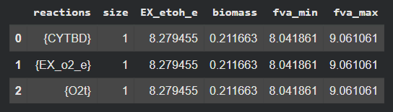
Figure 15: Single gene knock-out strategies predicted by OptKnock

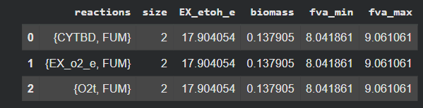
Figure 16: Double gene knock-out strategies predicted by OptKnock
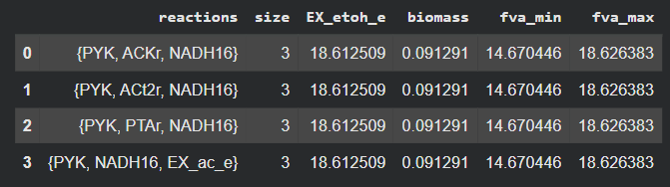
Figure 17: Triple gene knock-out strategies predicted by OptKnock

- The synthetic lethal genes identified under each condition are as follows:

- When glucose was used as the sole carbon source by setting the flux of the Glucose Exchange reaction was set as -10 ($\frac{mmol}{gDW -hr})$, 53 pairs of synthetic lethal genes were obtained. Some of these are given here:

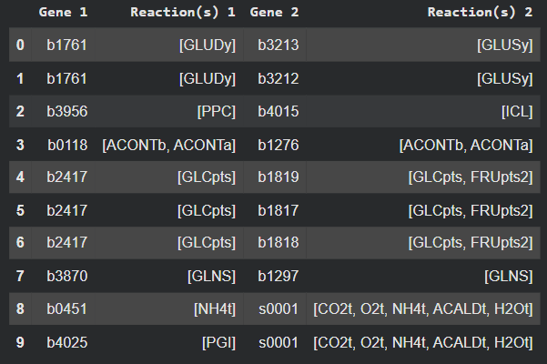

Figure 16: Some pairs of synthetic lethal genes when glucose was used as the sole carbon source

- When acetate was used as the sole carbon source by setting the flux of the Acetate Exchange reaction was set as -10 ($\frac{mmol}{gDW -hr})$ and that of the Glucose Exchange reaction was set as 0 ($\frac{mmol}{gDW -hr})$, 19 pairs of synthetic lethal genes were obtained. Some of these are given here:

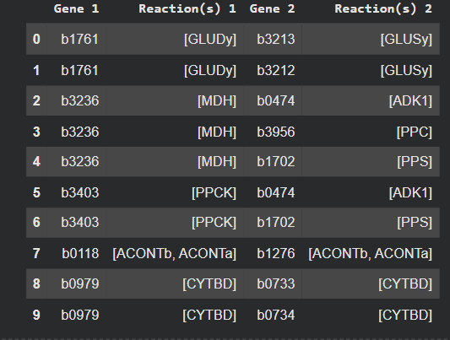

Figure 17: Some pairs of synthetic lethal genes when acetate was used as the sole carbon source

- Under the minimal condition, where glucose was used as the sole carbon source, 27 pairs of synthetic lethal genes were obtained. Some of these are given here.

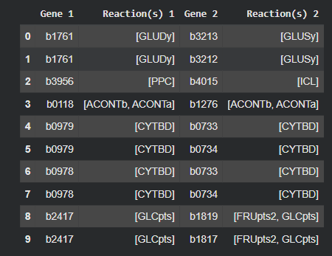

Figure 18: Some pairs of synthetic lethal genes when glucose was used as the sole carbon source in minimal media

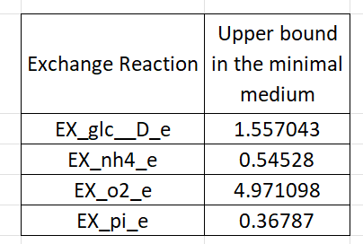
Figure 19: Upper bounds of various exchange reactions in the minimal medium with glucose as the sole carbon source

- The following 7 pairs of synthetic lethal genes were common across all the three aforementioned cases:

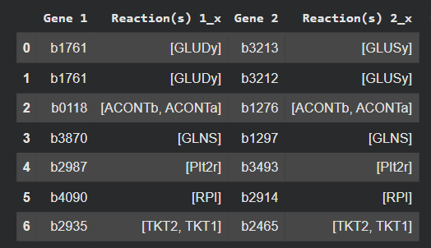

Figure 20: Pairs of synthetic lethal genes across all three cases

- 30 pairs of synthetic lethal genes were unique to the case when glucose was the sole carbon source, some of which are as follows:

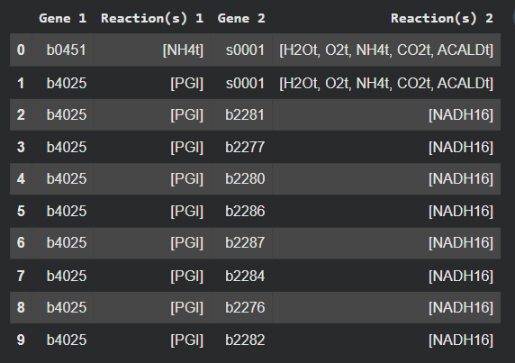

Figure 21: Some pairs of synthetic lethal genes unique to the case when glucose was used as the sole carbon source

- 8 pairs of synthetic lethal genes were unique to the case when acetate was the sole carbon source, which are as follows:

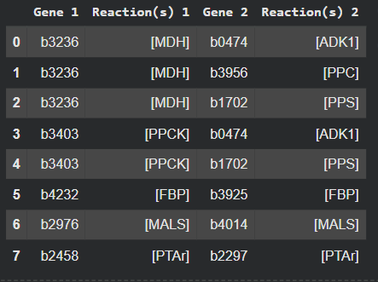

Figure 22: 8 pairs of synthetic lethal genes unique to the case when acetate was used as the sole carbon source

- 0 pairs of synthetic lethal genes were unique to the case when glucose was used as the sole carbon source in minimal media, some of which are as follows:

- Yes, synthetic lethality does depend on environmental conditions provided via the medium.
- The metabolic pathways active in a cell may differ, in general, from one medium to the other; this is governed by several factors, such as, for instance, which carbon or nitrogen is being provided in the medium, or whether the medium is aerobic and anaerobic in nature.
- Therefore, since different metabolic pathways operate to control the cellular phenotype in different growth conditions, different pairs of genes may be synthetic lethal pairs in medium conditions.
- For example, genes that encode enzymes that are involved in parallel pathways responsible for the synthesis of an amino acid may not be a synthetic lethal pair when the amino acid is provided in the medium; however, if the uptake of the amino acid is hindered (either by a dysfunctional copy of its transmembrane transport protein, or by its absence in the culture medium), such genes may form a synthetic lethal pair.

- The genes ‘gdhA’ (gene ID: b1761) and ‘gltB’ (gene ID: b3212) form a pair of synthetic lethal genes in all the cases described above.
- gltB codes for the large chain of Glutamate Synthetase, which catalyses the NADPH-dependent reversible conversion of L-glutamine to L-glutamate [4].
- gdhA codes for Glutamate Dehydrogenase, which catalyses the NADPH-dependent reversible conversion of α-ketoglutarate to L-glutamate in the presence of ammonia [4].
- The deletion of any one of the two genes still allows the synthesis of glutamate to take place. However, since these genes catalyse the only two pathways for glutamate synthesis, their simultaneous deletion is detrimental for glutamate production in the cell, which may hinder protein synthesis, leading to cell death [4].

- The only two parallel, or alternative, pathways responsible for the biosynthesis of glutamate are disrupted by the double deletion.

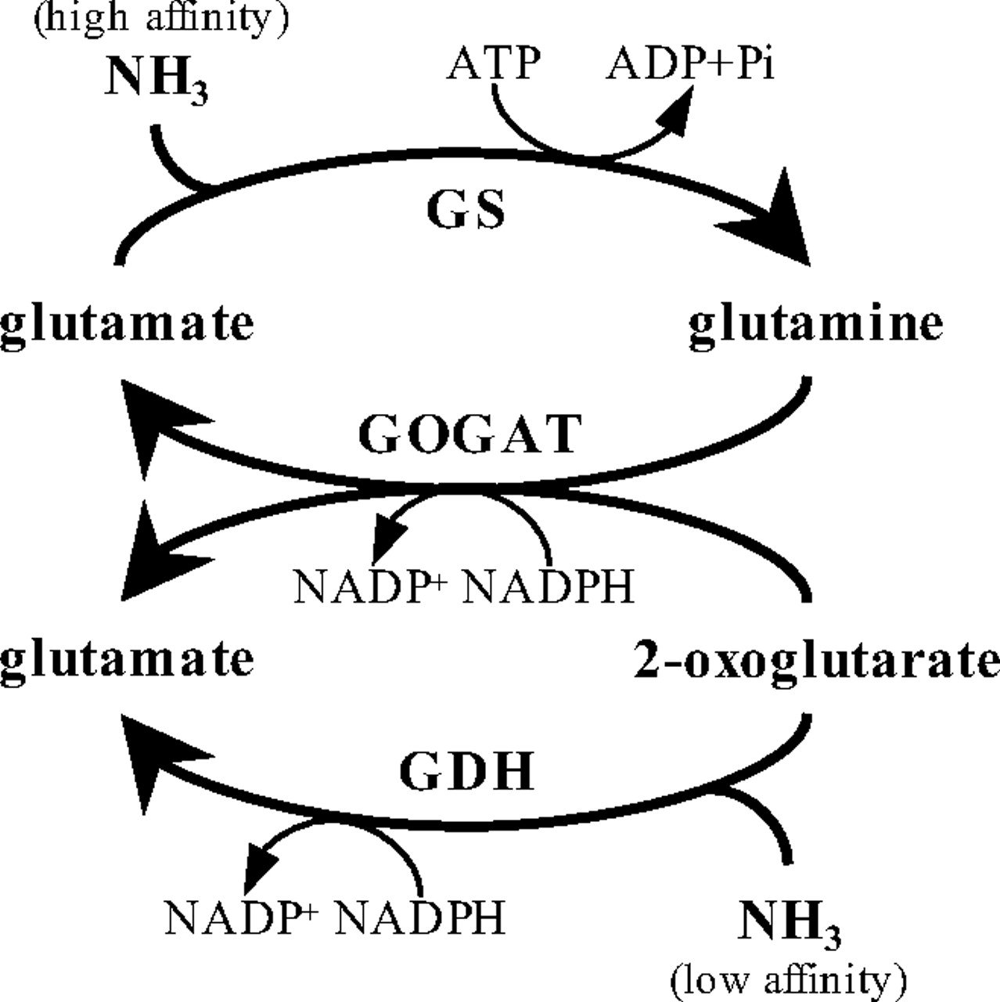
Figure 23: The central nitrogen metabolism circuit, obtained from [4]
GDH: reversible reaction catalysed by Glutamate Dehydrogenase,
GS/GOGAT: reversible reaction catalysed by Glutamate Synthetase

References:
- https://en.wikipedia.org/wiki/UDP-N-acetylglucosamine_1-carboxyvinyltransferase
- Brown ED, Vivas EI, Walsh CT, Kolter R. 1995. MurA (MurZ), the enzyme that catalyzes the first committed step in peptidoglycan biosynthesis, is essential in Escherichia coli. J Bacteriol 177:. https://doi.org/10.1128/jb.177.14.4194-4197.1995
- https://en.wikipedia.org/wiki/Fosfomycin
- D. Yan, Protection of the glutamate pool concentration in enteric bacteria, Proc. Natl. Acad. Sci. U.S.A. 104 (22) 9475-9480, https://doi.org/10.1073/pnas.0703360104 (2007).

